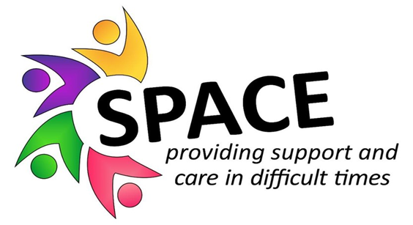

The Mental Health Support Team invites you to book your place in…
SPACE - Supporting Parents and Children Emotionally
SPACE is a new free programme for any parent who wants to better understand and support their children's emotions, as well as their own. Each session will last for 2 hours. The sessions will run at St Austell Family Hub, Woodland Road, St Austell, PL25 4RA.
This 5-session programme will cover:
- Managing different emotions
- Healthy coping strategies for dealing with stress
- Understanding what is meant by a Trauma Informed approach
- Understanding toxic stress and the flight/fight response
- Practical approaches to support children to regulate their emotions
- Understanding behaviour
- Building resilience in parents and children
- Adopting appropriate expectations of children
- Enhancing the parents’ ability to provide nurturing care
SPACE will run as a small supportive group of 6 – 16 participants and will be facilitated by Education Mental Health Practitioners Bev, Jenine and Jane.
Due to group size restrictions, places will be on a first come, first served basis. A waitlist will be created any additional sign ups.
To request a place please complete
the online form: https://forms.office.com/e/dSArkS1vAf

Booking deadline: Monday 30th October
Where: St Austell Family Hub
Session 1 | 2nd November 09:15-11:15
Session 2 | 9th November 09:15-11:15
Session 3 | 16th November 09:15-11:15
Session 4 | 30th November 09:15-11:15
Session 5 | 7th December 09:15-11:15
Commitment to all 5 sessions of the programme is expected.

